| DRIVETRAIN  Work Process |
| --- |
|  |

18/12/2021 - 08/05/2022

**Studying the perseverance and curiosity drivetrains:**

The drivetrain maneuvers the ground through a specified technique:

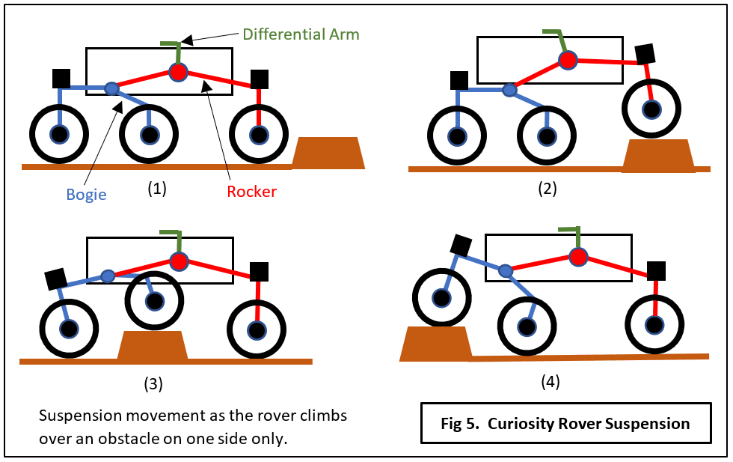

**Choosing them as the type of drivetrain we need:**

Because they have the most effective designs: robust capabilities to deal with uneven terrain because of its distributing of the payload over its six wheels uniformly

Suspension Structure: Suspension is the system of tires, tire air, springs, shock absorbers and linkages that connects a vehicle to its wheels and allows relative motion between the two.

It is divided to 3 parts:

* **Rocker:** Relative to the chassis, the rockers will rotate in opposite directions to maintain approximately equal wheel contact.
* **Bogie:** smaller linkage that pivots to the rocker in the middle and which has a drive wheel at each end.
* **Differential:** keeps it stable / connects rockers together /should be the center of mass

**Exploring the rev materials :**

exploring both the 2016 kit and the 2021 kit components list

* sketching approximately how the drivetrain will look :

( show pics of the sketches we made)

* choosing the materials for each part : wheels / motors / structural parts..
* giving it some approximate measurements

**Some of our pictures:**

